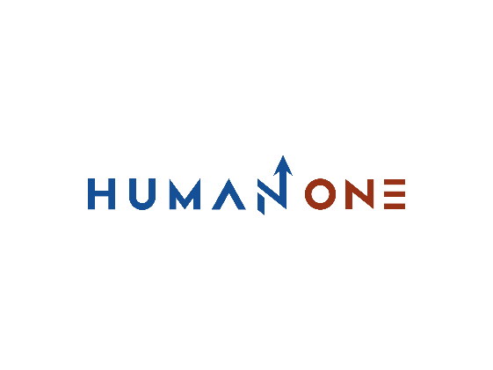

Services

Expertise

**EN**

**FR**

Get in touch

Company

Services overview

Consulting

# Digital Consulting



Let’s Talk

We are committed to our customers to keep them in tune with the demands of a constantly changing global market and in step with the latest technology trends.

Our expert consultants will assist you at every stage of the solution life cycle or software development.

To ensure predictability and efficiency, HumanOne quickly diagnoses and identifies technical challenges by applying a systematic approach to enterprise-level consulting. With our extensive technical and process skills, your innovative ideas will quickly be transformed into tools that will ensure your satisfaction.

# What we do

# 

1

Discover

Identify and prioritize the missions to be managed and determine the appropriate actions and solutions.

2

Elaborate

Define the necessary aspects to launch the development of the solution

3

Optimize

Improve existing processes or solutions, Determine the choice of technology to be used

**Discover**

* Identify and prioritize the missions
* Detail and elucidate the vision
* Determine the appropriate actions and solutions

**Elaborate**

* Define the necessary aspects and characteristics
* Proceed with the design of the solution
* Drawing up a roadmap for the development of the solution

**Optimize**

* Improve development processes and options
* Determine the choice of the technology to be used
* Respect of quality assurance

# What you get



A sophisticated vision of the solution or project features



Enumeration of the requirements, design and tree structure in order to start the further development.



Optimized quality, responsiveness, productivity and predictability of processes and solutions

## **Digital consulting highlights**



Deploy your development strategy by entrusting us with your projects. We identify and develop solutions and take into account short and medium-term objectives.



With the expertise of our experts, we guarantee the quality and efficiency of your solution by taking care of all aspects of engineering, business, and processes.



Our experienced consultants are here to help you convert your strategy into business results. We will ensure that the solution you choose can be deployed in the best conditions and aligned with your business needs

A performance oriented strategy

An integral approach

Global decision making

With HumanOne, take the path of intelligence and innovation

Get in touch

## **Why HumanOne**

**A consultancy based on the personalization of the offer.**

HumanOne distinguishes itself by offering a set of digital services combined with tailored consulting and advice, helping you achieve your business goals and giving you the means to get there. Thanks to the extended expertise of our consultants, and our results-oriented work methodology, we proactively manage the missions you entrust us with. Thanks to our experience, we are able adopt the best industry-standard processes to match and align with your vision.

Translated with www.DeepL.com/Translator (free version)

**security at all times**

Like the quality of our processes, we ensure the security of both our work processes and the security of the solutions and projects we develop on behalf of our customers. We demand the protection of your data and anticipate potential risks while eliminating possible loss of value.

**International standards**

HumanOne deploys all of its resources to develop effective, high-quality solutions. With HumanOne you choose a partner that is aligned with quality standards such as ISO 27001:9001, GDPR, A-SPICE. We favor solutions developed with the best practices in our industry and around the world.

**An utmost care to our clients**

In an ultra-competitive market, you need to rely on a quality partner who can quickly align with your vision. To do this, we deploy all of our resources and put our cross-functional and sectoral expertise at your disposal. Our technology consulting services focuses on solution or product design, thus creating a fruitful collaboration for the development of your solution.

**Consultancy services constantly up to date.**

We constantly monitor the quality of our services and advice in order to provide you with the best assistance for the development of your projects. We give a crucial importance to the treatment of your requests; thus, our consultants are regularly trained in order to reserve your optimal services for the realization of your projects in the best deadlines.

### **Centers of Excellence**

We make expertise and excellence inseparable ingredients for successful products and solutions. Our specialists are constantly invited to develop new skills in technologies and processes. Our centers of excellence, the result of the expertise of our consultants, are there to help you achieve your most ambitious goals.

